A REPORT
ON
DAILYGROCER v5.5: A SMART GROCERY AND ORDER HISTORY MANAGER
By

YARAPA VENU GOPAL AP23110011440
B.Bharadwaj AP23110010254
G.V.Raghavendra AP23110010444
Ch.Sai Santosh AP23110010313

Prepared in the partial fulfillment of the
FULLSTACK
AT
SMART BRIDGE



SRM UNIVERSITY, AP
(July, 2025)

+

Introduction:-
Welcome to GrocerEase, a modern and intelligent web application built using React.js, designed to offer users a seamless grocery browsing experience along with an integrated Resume Manager that supports full CRUD (Create, Read, Update, Delete) operations.
Designed using modern technologies like React, Tailwind CSS, Axios, and JSON-Server, the GarcerEase platform ensures a smooth, responsive, and fast user experience.
The Grocery section provides a visually appealing shopping interface with product listings, filtering capabilities, cart management, and wishlist features.
The Resume Manager is engineered as a robust CRUD module where users can create, edit, update, and delete resumes, fully integrated with JSON-Server acting as a lightweight backend.
GrocerEase combines elegance, performance, and functionality—making it a complete frontend project ideal for real-world usage and academic evaluations.

Scenario-Based Intro:-
Imagine you want to build a web app that not only provides a full grocery shopping experience but also includes a powerful Resume Manager tool for job seekers.
You log in to GrocerEase, where a clean and modern interface greets you. The homepage showcases featured grocery products and a special section for the Resume Manager. With one click, you access the Resume Manager dashboard, where you can:
- Create a resume
- Edit its fields
- Update contact, experience, and skills
- Delete unwanted resumes
- View all resumes in a card/table format
Every action you perform updates instantly since GrocerEase is powered by React state management, Axios API calls, and a local JSON-Server backend.
Meanwhile, users browsing the grocery store experience smooth navigation, product layouts, cart operations, and themed UI powered by Tailwind CSS.
Thus, GrocerEase serves both as a grocery browsing interface and a real-time resume management system.

Target Audience:-
GrocerEase is built for:
1. Everyday Users
Looking for an easy-to-use grocery shopping interface.
2. Students & Job Seekers
Who want a quick tool to create and manage resumes.
3. Developers & Learners
Interested in studying a project using:
- React.js
- Tailwind CSS
- Axios
- JSON-Server
- React Router DOM
- Context API
4. Academic Project Evaluators
Who evaluate skills in UI development, API integration, and CRUD logic.
.
Project Goals and Objectives:-
Develop a modern, responsive, and fully functional web platform that includes:
- Grocery browsing features
- Resume CRUD management
- Realistic UI using Tailwind
- Axios integration for API handling
- JSON-Server as a local backend
Objectives
- User-Friendly UI
Build clean pages for grocery browsing, cart, wishlist, and resume CRUD.
- Efficient Resume System
Enable users to create, update, view, and delete resumes easily.
- Modern Technology Stack
Utilize React, React Router DOM, Tailwind, Axios, and JSON-Server.
- Component Reusability
Follow modular architecture with reusable components.
- Performance & Scalability
Ensure fast loading, responsive design, and error handling.

Key Features:-
1. Grocery Store Interface
- Product listings
- Categories
- Wishlist
- Cart & Checkout
- Responsive layout
📄 2. Resume Manager (Full CRUD + API)
- Create new resumes
- Edit existing resumes
- Delete resumes
- View details page
- Axios-based data operations
- JSON-Server backend
🎨 3. Tailwind UI
- Gradient cards
- Responsive design
- Layout grid systems
🔗 4. Routing
- Navigate seamlessly using React Router DOM
🧰 5. API Handling with Axios
- GET, POST, PUT, DELETE operations
💾 6. JSON-Server Backend
- Local REST API
- db.json storage
- Fake backend for CRUD demo

PRE-REQUISITES:-
To build this project, you need:
✔ Node.js and npm
Required to run React and JSON-Server
Download:
https://nodejs.org/en/download/
✔ React.js
Installed via Vite:
npm create vite@latest
npm install
npm run dev
✔ JSON-Server
For creating REST API:
npm install json-server --save-dev
npm run server
✔ Tailwind CSS
Installed and configured using:
npm install tailwindcss postcss autoprefixer --save-dev
npx tailwindcss init -p
✔ Axios
API fetching library:
npm install axios
✔ Git (optional)
For project versioning.

Project structure:
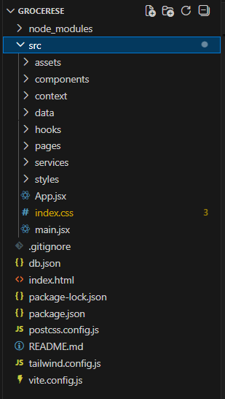
The project structure may vary depending on the specific library, framework, programming language, or development approach used. It's essential to organize the files and directories in a logical and consistent manner to improve code maintainability and collaboration among developers.

PROJECT FLOW:-
Project demo:
Demo link:
https://github.com/BollapalliBharadwaj/Grocer_Ease_Demos
Use code in:
https://github.com/BollapalliBharadwaj/Grocer_Ease1
Project Flow
Milestone 1: Project Setup
- Installed all dependencies (React, Tailwind, Axios, JSON-Server)
- Created component structure
- Linked pages through React Router DOM
Milestone 2: Grocery Website UI
- Designed UI components
- Added navigation bar
- Implemented cart & wishlist
- Added product layout
Milestone 3: Resume Manager (CRUD)
✔ CREATE
Form to add new resume
POST → JSON-Server
✔ READ
List all resumes
GET → /resumes
✔ UPDATE
Edit resume
PUT → /resumes/:id
✔ DELETE
Remove resume permanently
DELETE → /resumes/:id
All operations tested using Axios.
.
PACKAGE.JSON:

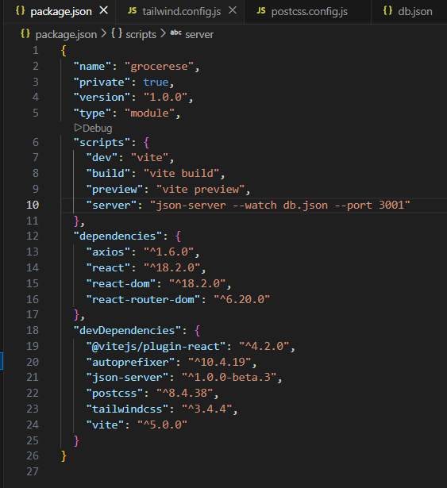

.Main.tsx:

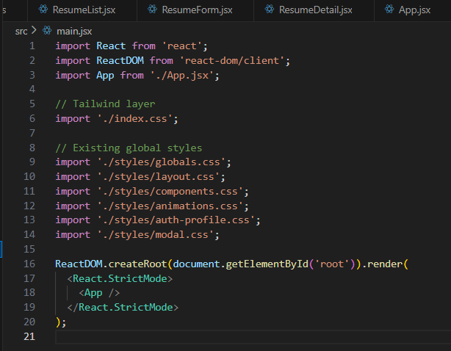
resumeApi.js (Axios API Integration):
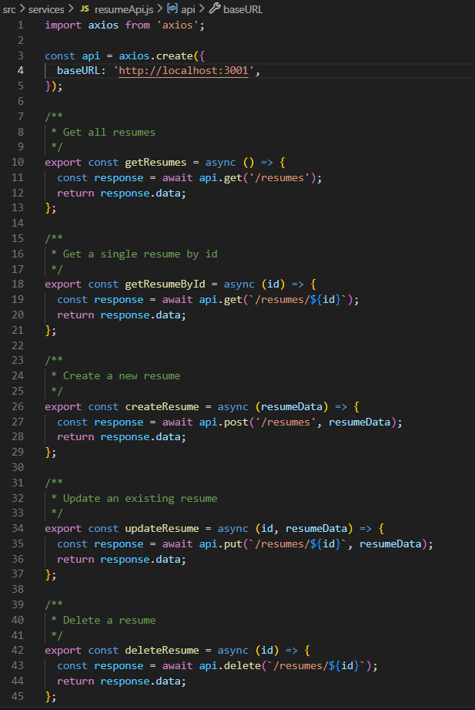
db.json:
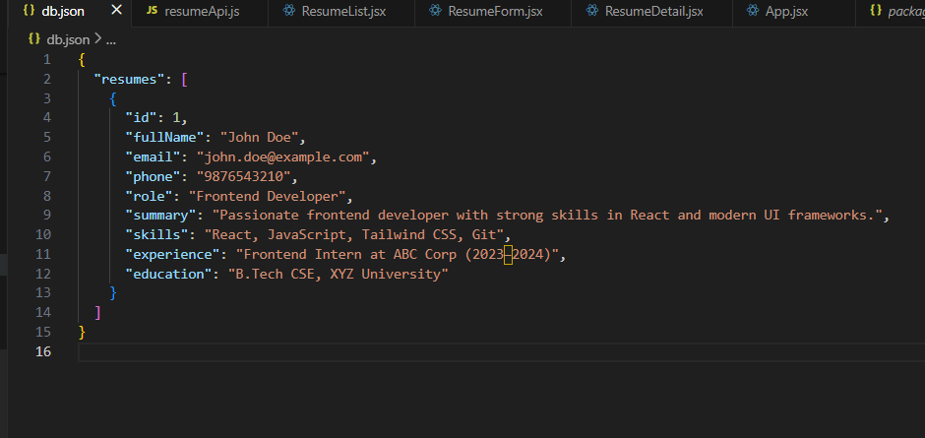
CRUD Components:
ResumeList.jsx
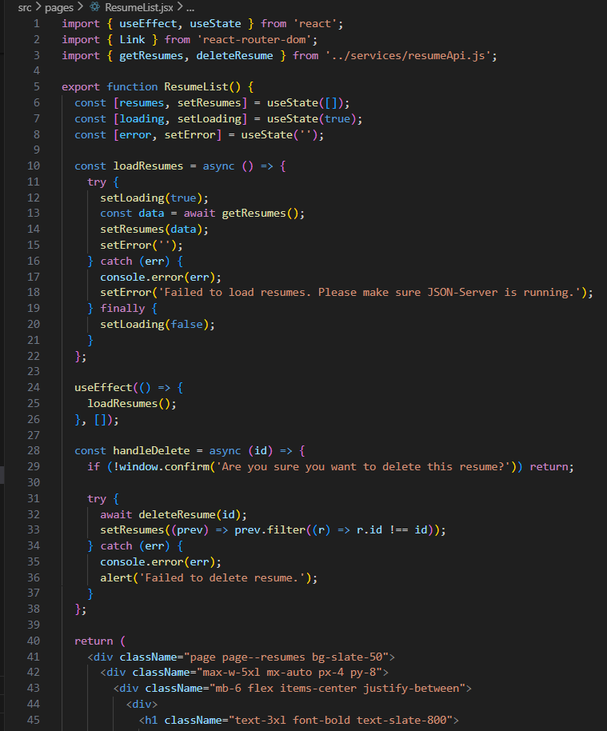

ResumeForm.jsx(create+Update):
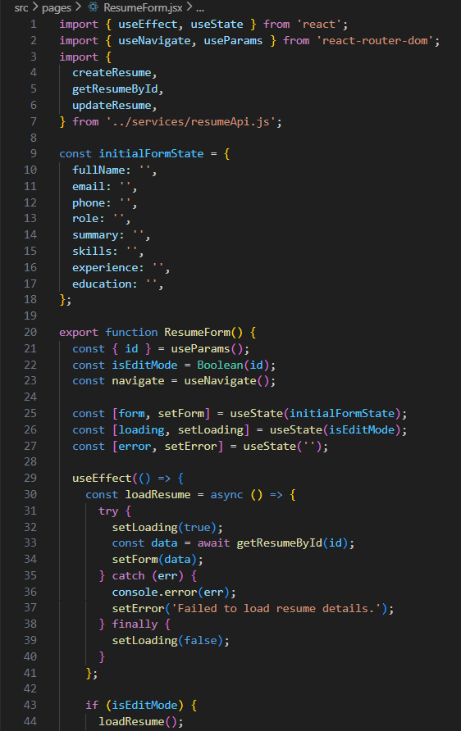

ResumeDetail.jsx(READ single Resume):

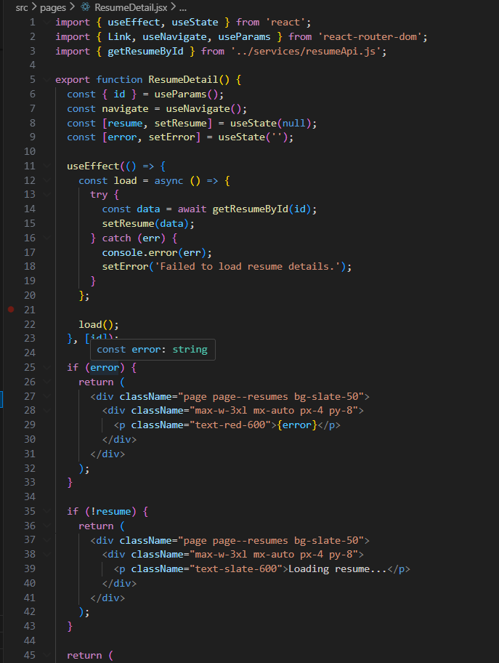

Project Execution
After completing the full development of the GrocerEase application along with the Resume Manager (CRUD module), run the following two separate processes to launch the complete project experience:
1. Start the Backend (JSON-Server):
npm run server
This command starts the JSON-Server backend on
http://localhost:3001/resumes
which is used for Resume CRUD operations.

2. Start the Frontend (React Application):
npm run dev
This runs the frontend on:
👉 http://localhost:5173
Once the application launches:
- Browse the GrocerEase homepage
- Use the navigation bar
- Explore grocery-related pages (Shop, Cart, Checkout, Wishlist, etc.)
- Navigate to the Resume Manager section to test Create, Read, Update, Delete operations

Home Page:
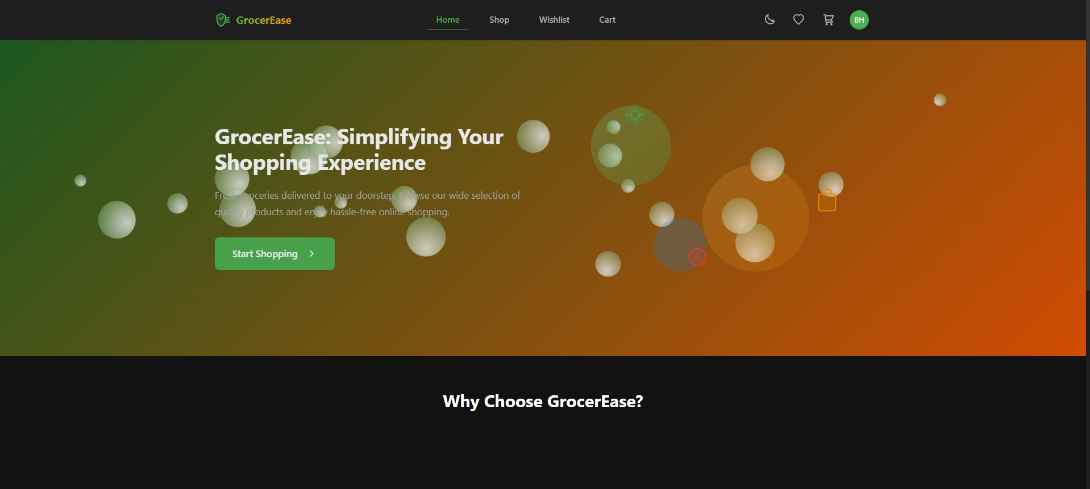

Resume List Page (Read + Delete):

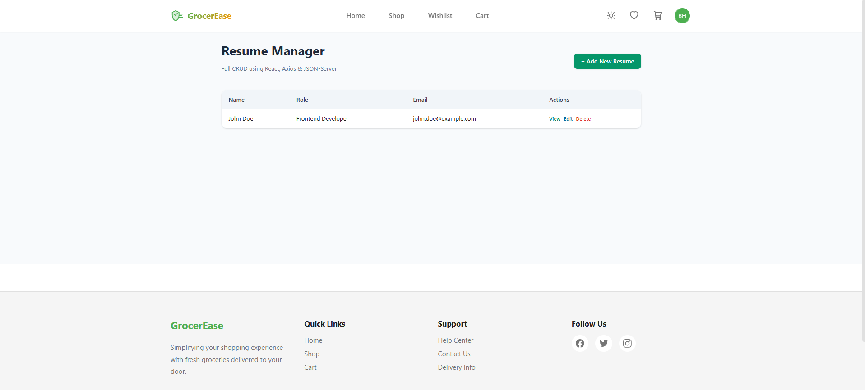
Add Resume Page (Create):
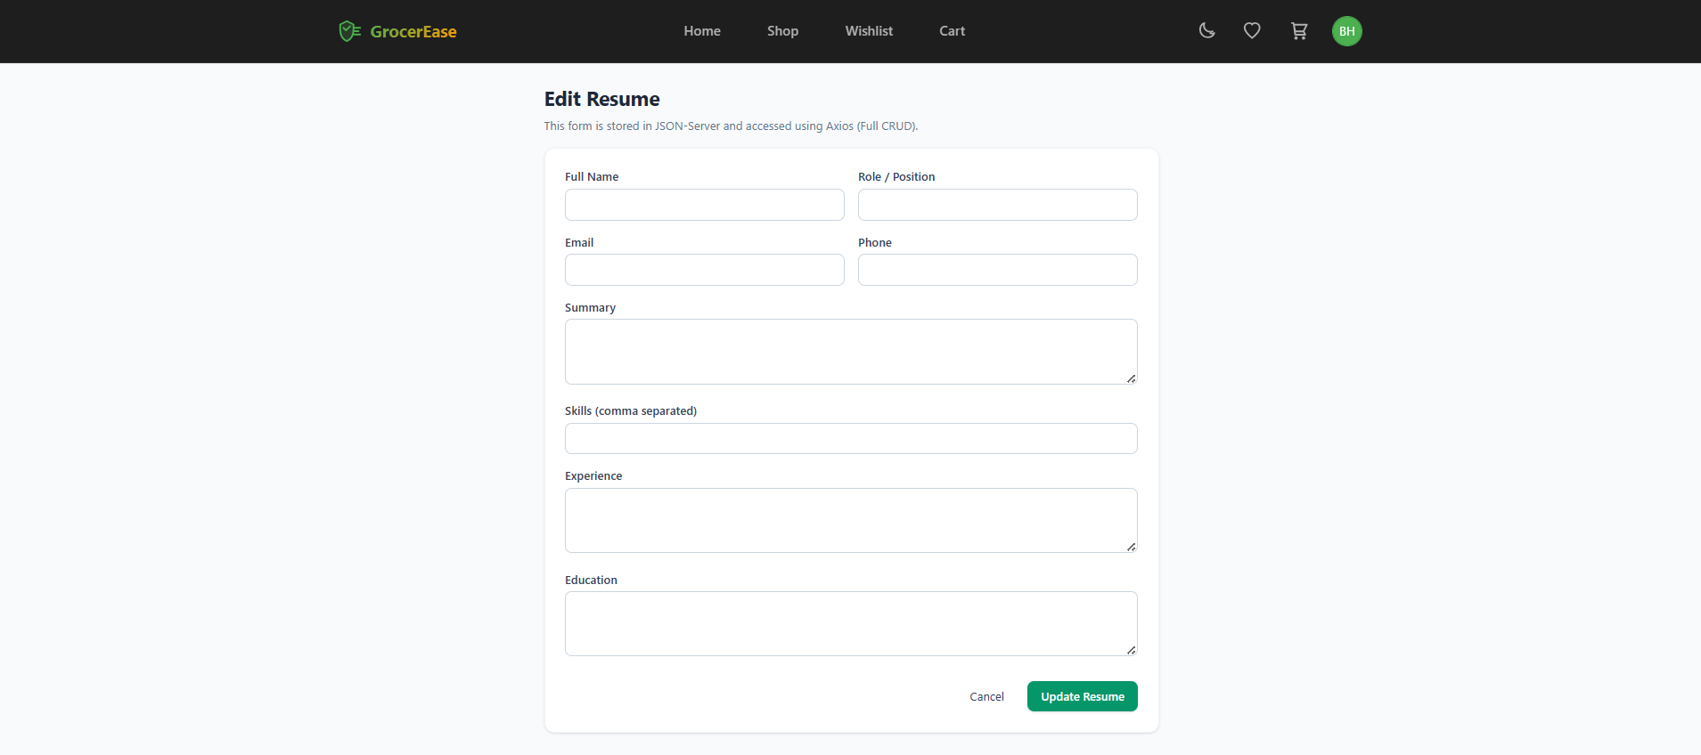

Edit Resume Page (Update):
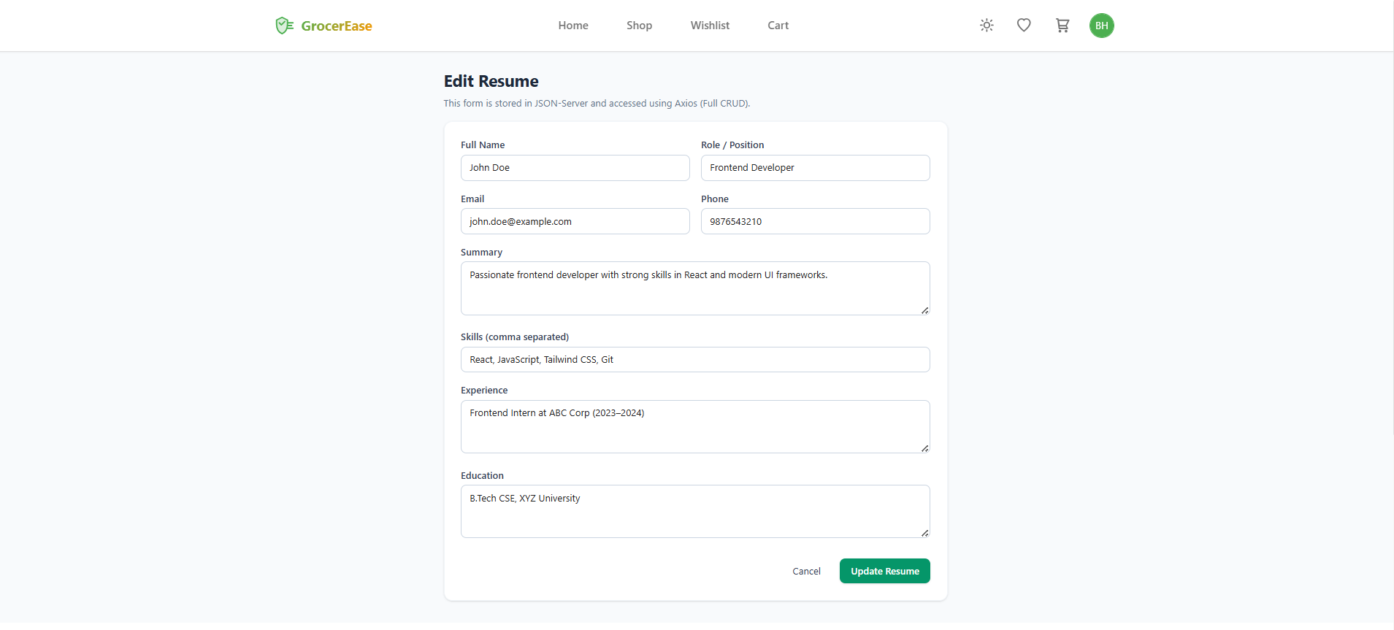

Resume Details Page (Read Single Item):
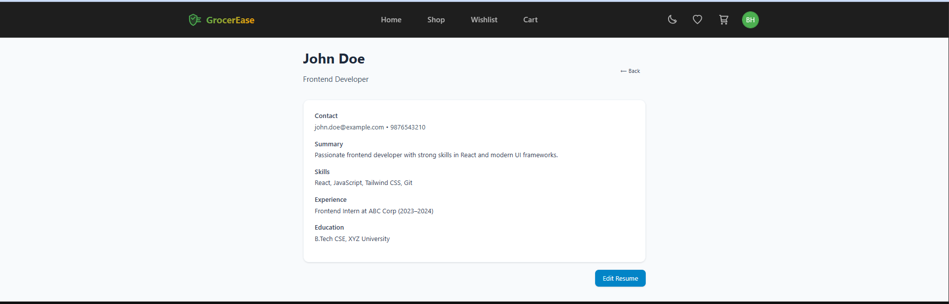

Grocery Shop Page:
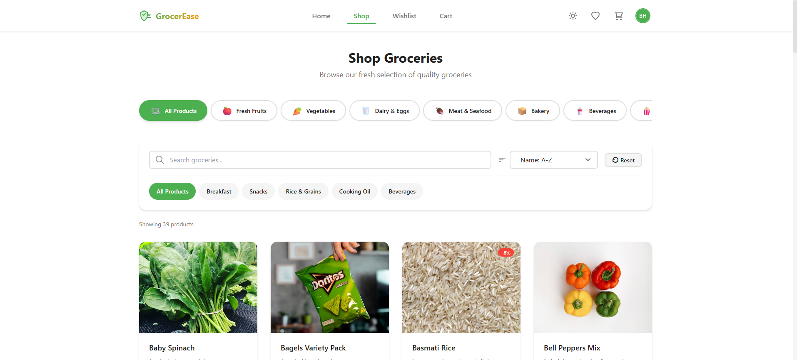

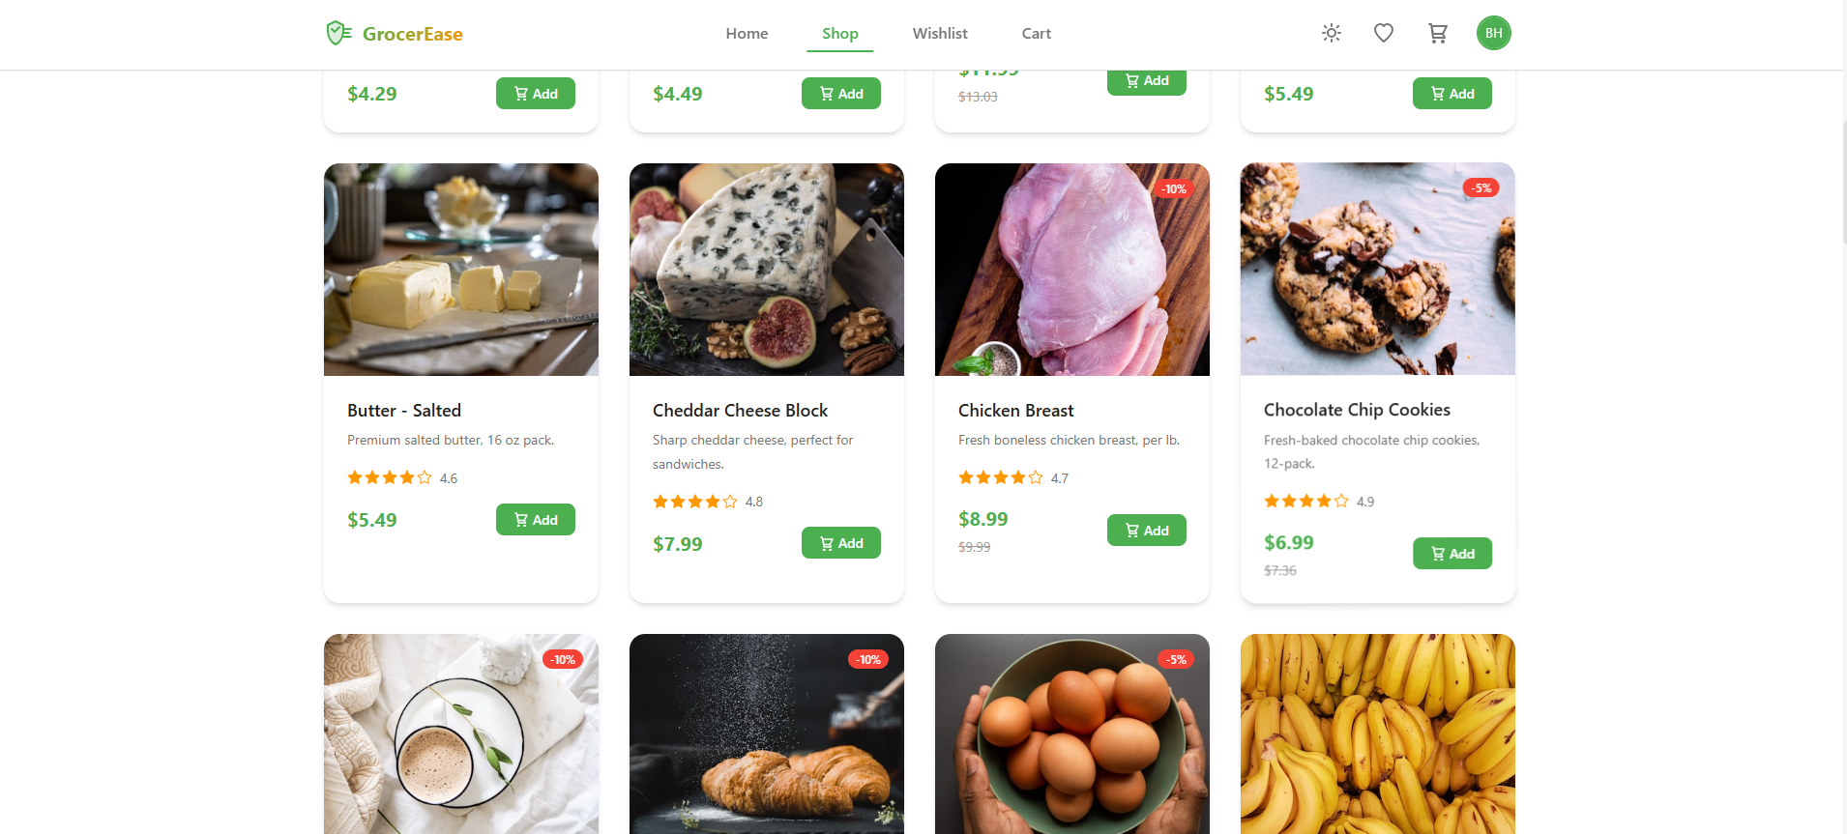

Cart Page:

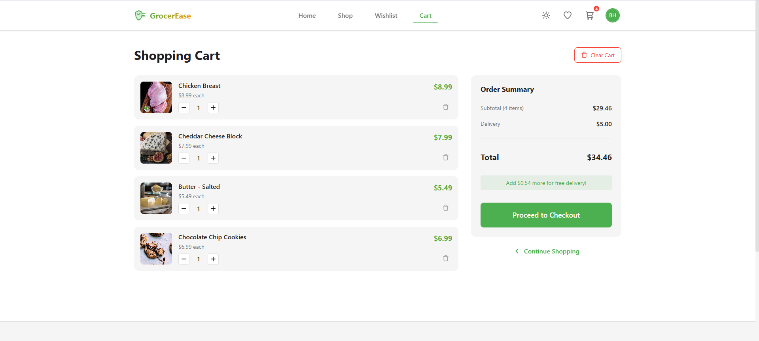
Checkout Page:

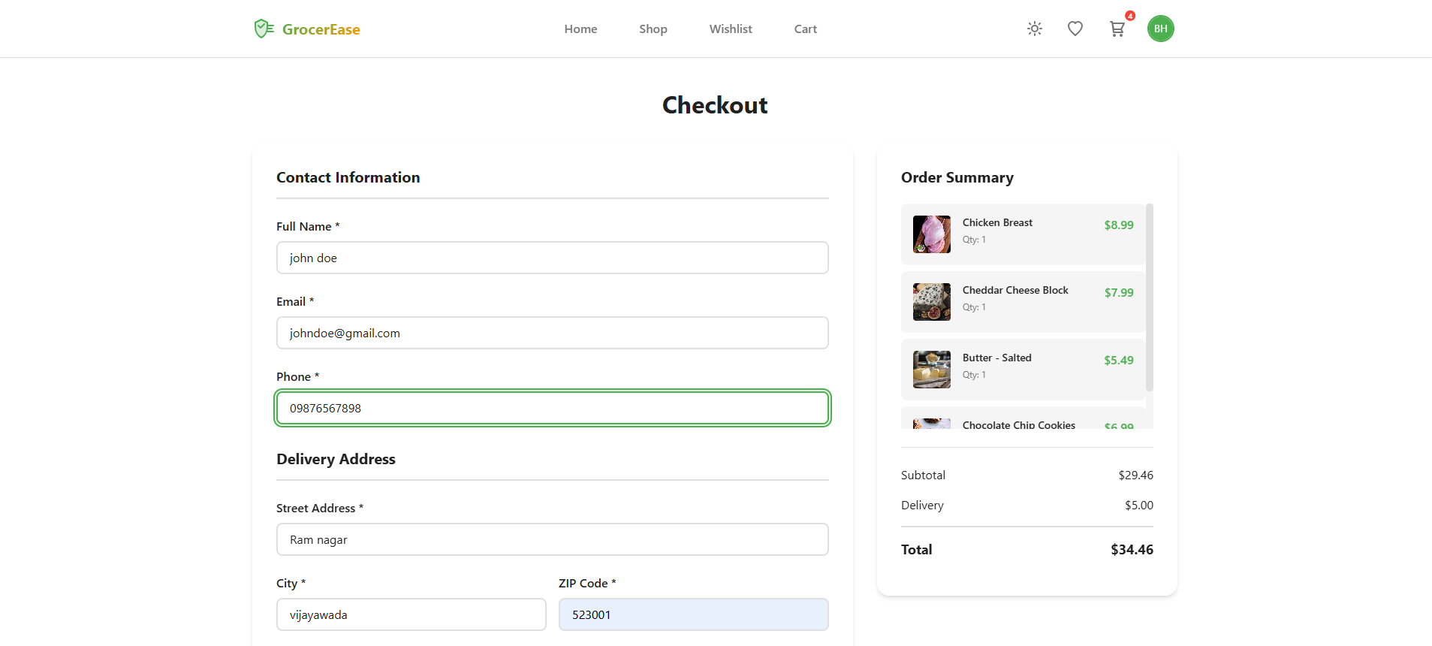
JSON-Server Output:
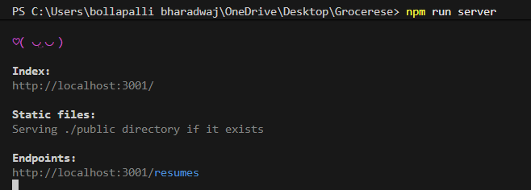
Project Demo Link:
https://github.com/BollapalliBharadwaj/Grocer_Ease_Demos

